NAME – ANIRUDDHA PRATAP SINGHPRN :25070122247 Batch – C2 COURSE – JAVA
ASSIGNMENT No: 12
TITLE: Write a Java program to create and use user-defined packages.
Problem Statement: Write a Java program to create and use user-defined packages.
Theory: Packages are used to organize related classes and interfaces into namespaces. User-defined packages improve code organization, reduce naming conflicts, and enhance reusability. They also support access protection and modular application development. Java packages simplify project management by grouping logically related components together. Largescale software systems extensively use packages.
PROGRAM
// First Interface
interface Printable {
void printDetails();
}
// Second Interface
interface Switchable {
void turnOn();
}
// Class implementing multiple interfaces
class SmartDevice implements Printable, Switchable { String deviceName = "Smart TV";
// Implementing Printable method
public void printDetails() {
System.out.println("Device Name : " + deviceName); }
// Implementing Switchable method
public void turnOn() {
System.out.println(deviceName + " is turned ON."); }
}
// Main class
public class InterfaceDemo {
public static void main(String[] args) {
// Creating object
SmartDevice device = new SmartDevice();
// Calling interface methods
device.printDetails();
device.turnOn();
}
}
OUTPUT
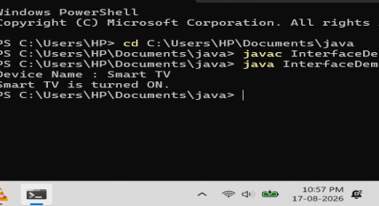
Exercise
1.Create a Java program by developing user-defined packages for a College Management System. Create separate packages for student and faculty details, and display their information using classes from these packages.
Program Structure:
CollegeManagement
│
├── student
│ └── Student.java
│
├── faculty
│ └── Faculty.java
│
└── CollegeManagement.java
Source code:
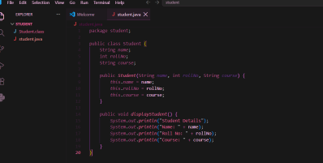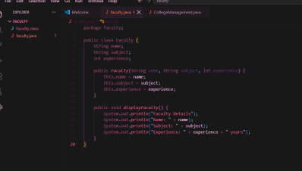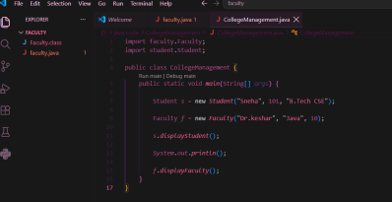Output:
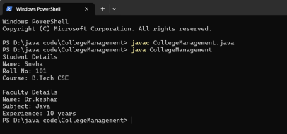
2. Create a Java program by developing a user-defined package named library that contains a class to store and display book details such as book ID, title, author, and price. Import the package into the main program and display the book information.
Program Structure:
LibraryManagement
│
├── library
│ └── Book.java
│
└── LibraryManagement.java
Source code:
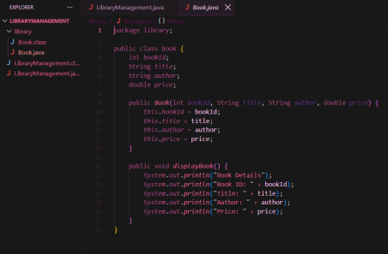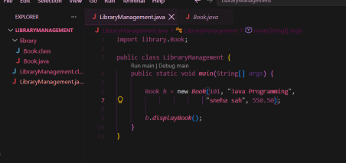Output:
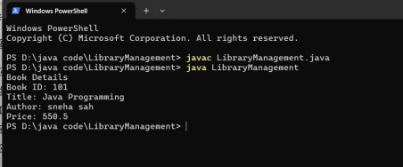
Conclusion
Thus, the experiment was successfully completed by creating and using user-defined packages in Java. We created separate packages for student, faculty, and library details, and accessed their classes in the main program using the import statement. This experiment helped us understand how packages improve program organization, code reusability, and modularity in Java.

